To consider the effectiveness of an active learning experience of an integrated GPS guided fieldwork to find geotaged points of interest, philosophy and Microsoft Office experience to introduce Geographic Information Systems
Method: Willing students from 2015 -2018 were asked for anonymous feedback for an ESST 3006 lab. Statistics were gathered using surveymonkey.com. This data was gather to determine whether students responded positively towards having a lab where their space was changed up and they were required to do a treasure hunt and explore the use of GPS without more than a two minute debriefing session and a guide on how to use the GPS unit. The lab handout with the grading rubric can be found below.

GIS 3006: Introduction to Geographical Data

Learning objectives:
- To collect data that is complementary to spatial data
- To gain a greater understanding of attribute data and types of data
- To gain a baseline understanding of Global Positioning Systems
Section A
This lab exercise is supposed to give you a greater appreciation of spatial data collection. Spatial data refers to the X and Y coordinates used to reference a site or location. It refers to the data that can be mapped about a physical object and is represented by numerical values in a geographic system. The co-ordinate data (Table 1) that you are given should be used to locate the trees. You are then responsible for providing additional information (Table 2) about these trees.
Tree number | Latitude | Longitude
1 | N 10˚38’ 33.3” | W -61˚24’ 01.3”
2 | N 10˚38’ 27.7” | W -61˚23’ 57.8”
3 | N 10˚38’ 28.9” | W -61˚24’ 00.1”
4 | N 10˚38’ 29.9” | W -61˚24’ 01.3”
5 | N 10˚38’ 30.4” | W -61˚24’ 01.1”
6 | N 10˚38’ 32.2” | W -61˚24’ 02.6”

After completing Table 2, please open an excel spreadsheet and add the collected data and the spatial data. Please ensure to save the file as a .csv file. Ensure that there are no spaces when you are saving the file name. Remember that you always need to connect to the relevant folder in ArcCatalog before trying to find the folder in ArcGIS. Then import the data into ArcGIS. Take a screenshot of the tree locations in ArcGIS and another showing the information on one of your trees.
(4 points)
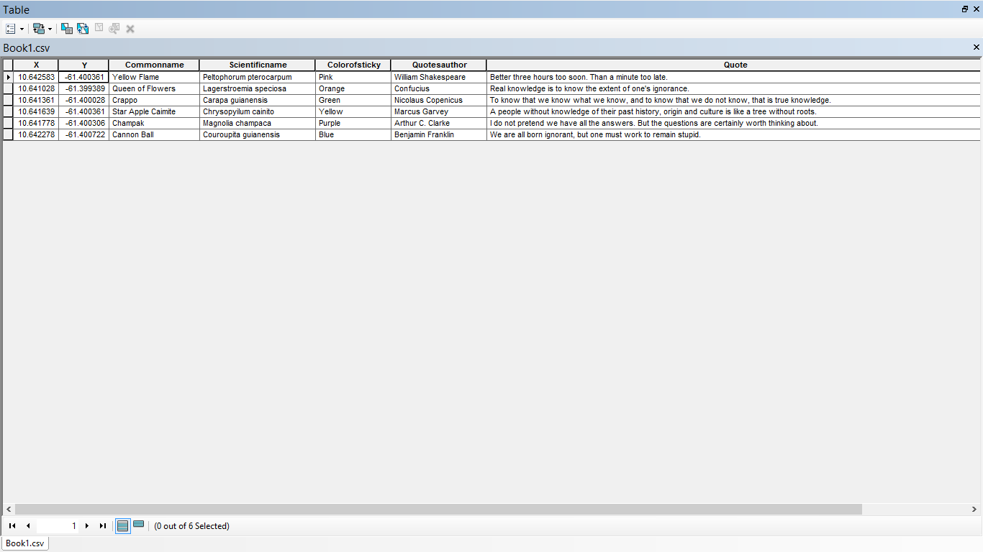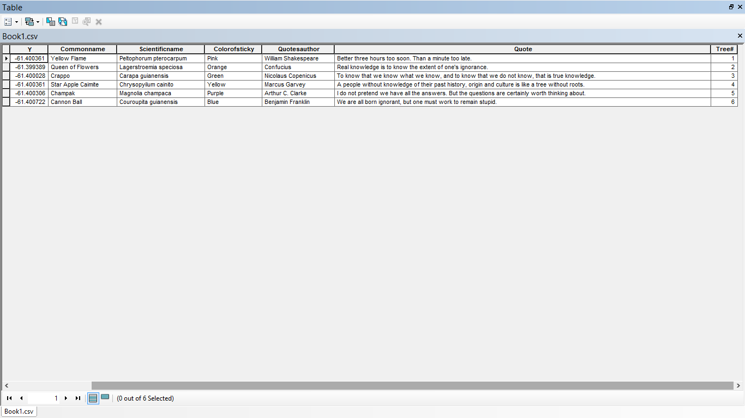

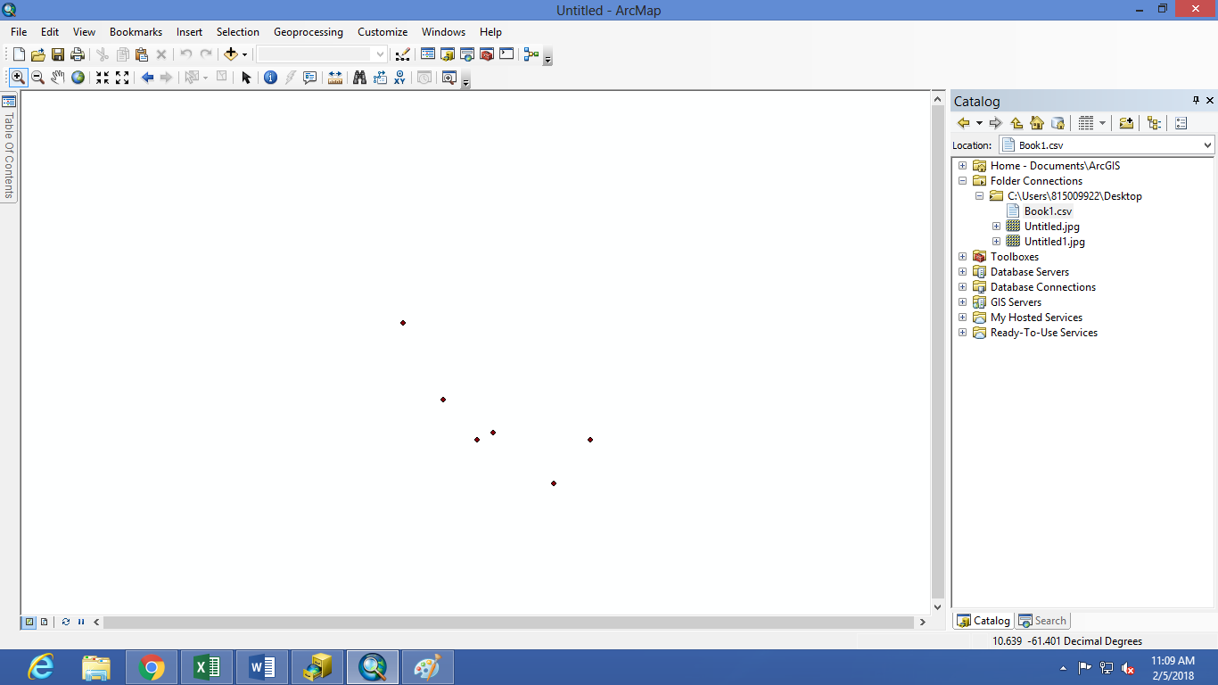
Section B
Based on this lab exercise, define attribute data (2.5 points).
Attribute data is qualitative data that is used for recording and analysis which has to be converted to discrete data for usage. It is the data that is different to the spatial characteristics.
Attributes are in different forms and can be categorized into different forms: nominal, ordinal and interval/ ratio. Nominal attributes provide descriptive information, such as vegetation type, city name or soil type. There is no implied quantitative information. Ordinal data implies a ranking or order can be derived. It can be descriptive, such as high, mid, and low, or it can be numeric, such as erosion class. Interval or ratio attributes are recorded as real numbers and are often numeric in scale, such as area, length, height, and weight. What different data types do we have (2.5 points)?
Different types of data found are ordinal and interval/ratio.

Tree# | X | Y | Commonname | Scientificname | Colorofsticky | Quotesauthor | Quote
1 | 10.64258 | -61.4003611 | Yellow Flame | Peltophorum pterocarpum | Pink | William Shakespeare | Better three hours too soon. Than a minute too late.
2 | 10.64103 | -61.3993889 | Queen of Flowers | Lagerstroemia speciosa | Orange | Confucius | Real knowledge is to know the extent of one's ignorance.
3 | 10.64136 | -61.4000278 | Crappo | Carapa guianensis | Green | Nicolaus Copenicus | To know that we know what we know, and to know that we do not know, that is true knowledge.
4 | 10.64164 | -61.4003611 | Star Apple Caimite | Chrysopyilum cainito | Yellow | Marcus Garvey | A people without knowledge of their past history, origin and culture is like a tree without roots.
5 | 10.64178 | -61.4003056 | Champak | Magnolia champaca | Purple | Arthur C. Clarke | I do not pretend we have all the answers. But the questions are certainly worth thinking about.
6 | 10.64228 | -61.4007222 | Cannon Ball | Couroupita guianensis | Blue | Benjamin Franklin | We are all born ignorant, but one must work to remain stupid.
(6 points)
Please show all working for the conversion for DMS to DDs.
Dºm¹Sec^{ll} => DD
= D + 1/60 + 1/3600
= 10.xxx or -61.xxx

Some of the data from the survey monkey survey is shown below.
